Comparing the modified beyma slot tweeter, mounted with and w/o waveguide.

I mounted the slot tweeter on a board approximately the size of my expected finished speaker (20 ½ in ht x 11 in width), in its vertical and offset horizontal position, set-up to swivel horizontally for measurements. To establish a flat(ish) baseline I eq’ed the with waveguide at 15 degrees off-axis, maintaining that file for each measurement.

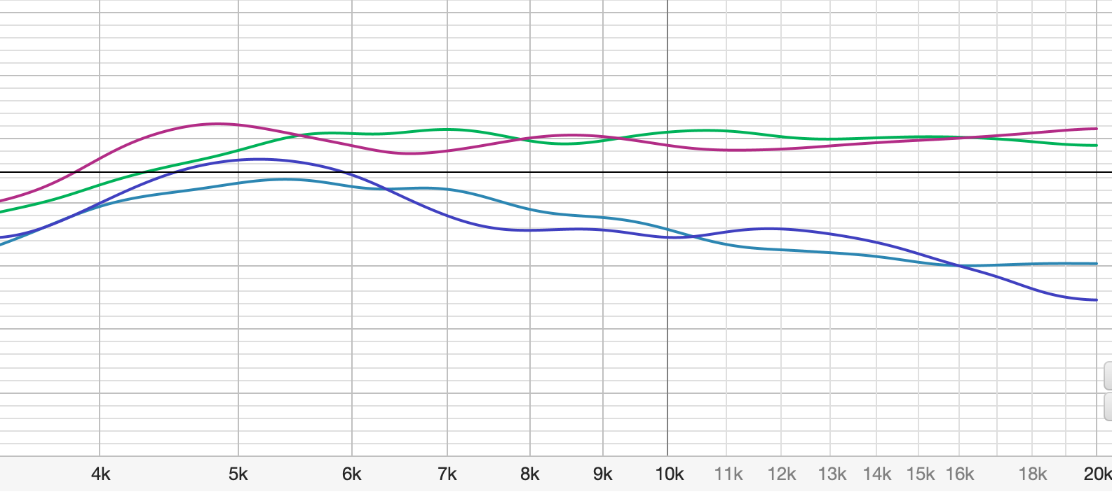
Green line: waveguide (sanded and finished version), red no waveguide, both on axis.
Lighter blue waveguide, dark blue no waveguide, both at 60 degrees off-axis horizontal.
(1/3d octave smoothing graph, vertical majors 5dB, each line 1dB).
______________________________________________
Vertically, unsurprisingly, both with and w/o waveguide are very narrow. While the waveguide appears to provide a bit more support through 10 and 15 degrees, at 20 degrees both dip 12- 14kHz range.

______________________________________________
The following graphs are comps of the unsmoothed stock printed waveguide vs finished waveguide (1/3rd octave smoothing graph, vertical majors 2dB, each line 1/2dB, to provide more detail).

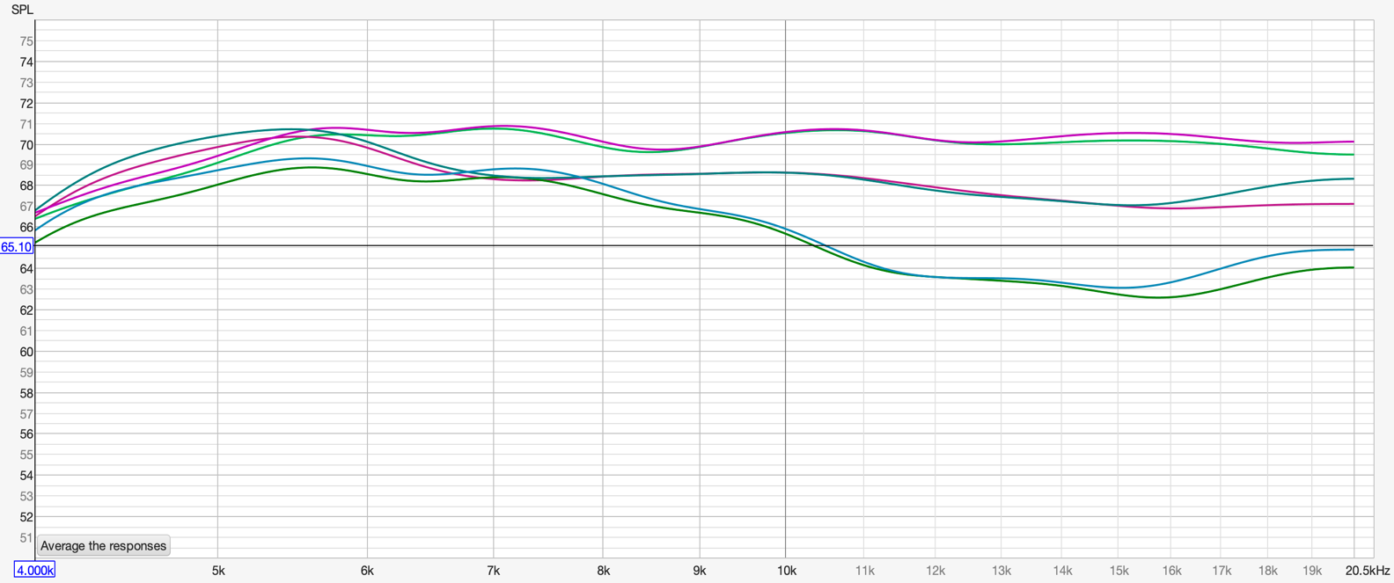Line reference at 20kHz: on-axis top two lines, 30 degrees middle set, 45 degrees bottom set. Interestingly, in each set the stock unsmoothed exhibits a rising tendency.

Removing the graph octave smoothing at the 30 degree measurements (below) shows separation @ 16kHz.
(graph vertical majors 2dB, each line 1/2dB)

